**Activity: Grasshopper Dissection**

Insects are the most diverse class of animals on the planet with over 1 million named species. Scientists estimate that there are millions more species to be classified. Preserved grasshoppers, from the order Orthoptera, are excellent specimens to explore basic insect anatomy. The lubber grasshopper (*Romalea*) is often used because it is large and readily available. Like many grasshopper species, it is an agricultural pest.

**Directions:** Watch the video on grasshopper dissection and answer the questions.

1. What segments of the thorax are the forewings and hindwings attached?

**The forewings are attached to the mesothorax, and the hindwings are attached to the metathorax.**

1. What is the purpose of the tympanum?

**The tympanum is located under the hindwings and is responsible for detecting sound. It vibrates when hit by sound waves, similar to an eardrum.**

1. What is the purpose of the spiracles and tracheae?

**The spiracles are a means to get gas such as oxygen into the body, and tracheae carry gas from the spiracles throughout the body.**

1. Label the following structures on the figure below: antennae, spiracles, tympanum, compound eyes, ocelli

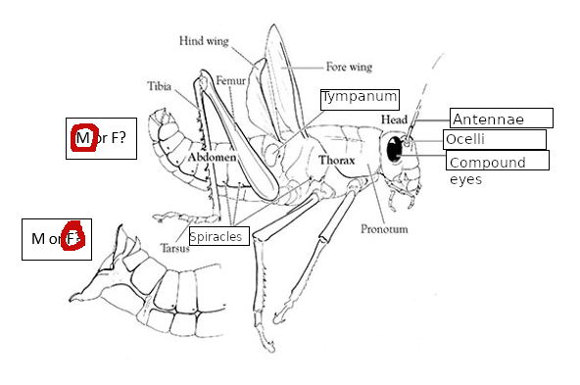

1. On the figure above, circle which structure belongs to a female (F) and which to a male (M).

1. What is the purpose of an ovipositor?

**Ovipositors allow female grasshoppers to deposit eggs underground.**

1. On the figure below, label the following structures: Malpighian tubules, gastric caeca, ventriculus, crop

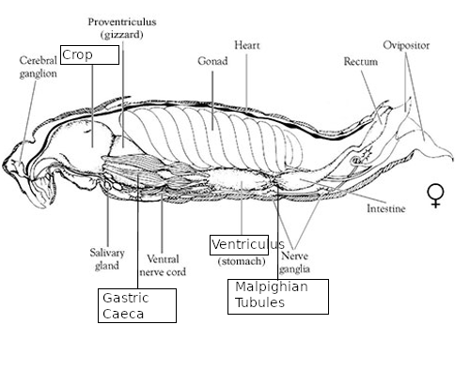

1. What is the purpose of Malpighian tubules?

**Malpighian tubules connect the digestive tract to the body cavity and aid in nutrient uptake while removing nitrogenous waste.**